Task scheduling optimization and fairness index design in collaborative AI computing platform
Zhanyi Qi
Wake Forest University,Winston Salem,27106,USA
zhanyi.qi@outlook.com

Abstract—The platform faces the dual challenges of efficiency and fairness in task scheduling. The traditional efficiency-oriented algorithm easily leads to the monopoly of "the strong will always be strong" resources, which leads to the long-term idleness of weak nodes and the withdrawal of participants. However, the classical fairness theory is difficult to adapt to the heterogeneous requirements of AI tasks for computing, communication and energy consumption. Therefore, this paper proposes a dynamic task scheduling optimization framework that integrates the three-dimensional fairness index of "time domain-space domain-result". Firstly, a compound fairness quantitative model based on Gini coefficient is designed to measure the consistency of task waiting opportunity, node load and completion quality respectively, so as to solve the one-sided problem of single index; Secondly, a dynamic weight scheduling algorithm driven by reinforcement learning (RL) is constructed, and the efficiency and fairness weights are adaptively adjusted through system state feedback to realize real-time optimization of resource allocation. Experimental results show that, in the high-load simulation environment, the algorithm improves the compound fairness by 32% without losing the system throughput, which is significantly better than the traditional FIFO, load balancing and fixed weight RL strategy. The research provides theoretical support and technical path for the sustainable resource scheduling of collaborative AI platform.
Keywords—Task scheduling; Fairness index; AI computing platform; Reinforcement learning; Dynamic weight

Introduction
With the large-scale application of AI technology, a single computing node can no longer meet the needs of large-scale model training and real-time reasoning. Collaborative AI computing platform has become a key infrastructure to support complex AI tasks by integrating heterogeneous computing resources across institutions and regions. Such platforms usually adopt distributed collaborative architecture, multi-party joint modeling in federated learning, device-cloud collaborative reasoning in edge computing, and multi-node parallel computing in supercomputing center [1]. Task scheduling strategy needs to optimize both system efficiency and fairness of resource allocation in a dynamic and changeable environment. Although the traditional scheduling algorithm can improve local efficiency, it is easy to lead to the resource monopoly phenomenon of "the strong will always be strong"-the nodes with strong computing power continue to get tasks, while the weak nodes are idle for a long time, which eventually leads to the risk of participants quitting.
In the collaborative AI computing platform, task scheduling is the core link, and its goal is to efficiently allocate computing tasks submitted by users to appropriate computing resources for execution [2]. However, due to the heterogeneous, dynamic and multi-tenant characteristics of the platform, task scheduling faces great challenges. At the same time, how to reflect fairness in resource allocation and ensure that different users or tasks can get a reasonable share of resources is also a crucial issue [3].
Genetic Algorithm (GA) is an optimization algorithm that imitates the natural evolution process. In task scheduling, the processing time of the task can be used as the gene code, and the optimal solution can be obtained by randomly generating the initial population, selecting, crossover and mutation, and iteratively optimizing the scheduling scheme. The advantage of GA is that it can comprehensively consider various factors and realize global optimization [4]. Ant Colony Optimization (ACO) is an optimization algorithm based on "ant colony intelligence". In task scheduling, tasks can be regarded as ants, and idle resources can be regarded as the path that ants pass. By simulating the process of ants looking for the shortest path, tasks can be assigned to appropriate resources. The advantage of ant colony algorithm is that it can optimize the resource utilization of tasks [5]. Particle Swarm Optimization (PSO) is an optimization algorithm based on swarm intelligence. In task scheduling, task and resource node can be regarded as a particle, and the speed and position of the particle can be optimized iteratively to find the optimal scheduling scheme. The advantage of particle swarm optimization algorithm is that it can quickly find the optimal solution in the search space [6-7].
Efficiency-oriented scheduling aims at minimizing the average completion time, and adopts GA, PSO or deep reinforcement learning (DRL) in heuristic algorithms, but ignores the difference of resource contribution of different participants, which leads to the decline of the overall participation of the system under long-term operation [8-9]. Although the classical theories Max-Min Fairness and Proportional Fairness can ensure the mathematical fairness of resource allocation, they do not consider the particularity of AI tasks-the sensitivity of different tasks to calculation accuracy, communication delay and energy consumption is significantly different, and simple average allocation may lead to overtime of key tasks or waste of resources [10]. The particularity of collaborative AI platform further aggravates this contradiction. The computing power span of nodes reaches 10³ orders of magnitude, the task arrival is random, and the node load fluctuates violently with time. Some tasks need to be completed by multiple nodes, and the delay of a single node will trigger a chain reaction. In this context, how to design a task scheduling mechanism that gives consideration to efficiency and fairness has become a key issue to improve the sustainability of collaborative AI platform.
This study constructs a multi-dimensional fairness quantification framework in dynamic environment, and develops an adaptive task scheduling algorithm based on this framework. A composite evaluation model including time-domain fairness (equal opportunity for task waiting), spatial fairness (load balancing of nodes) and result fairness (consistent quality of task completion) is proposed to solve the one-sidedness problem of single index. Based on RL, an adaptive weight adjustment mechanism is constructed, so that the scheduling strategy can dynamically adjust the fairness-efficiency priority according to the system state.

Multi-dimensional fairness index design
In the collaborative AI computing platform, fairness indicators need to be quantified from three dimensions: time domain, space domain and result, so as to comprehensively evaluate the fairness of resource allocation [11]. The following dimensions are defined respectively and combined into a composite fairness index.
(1)Time domain fairness
Time-domain fairness pays attention to the equal opportunity of tasks in waiting time, and avoids some tasks from staying for a long time. The Gini coefficient is used to measure the inequality of waiting time, and the smaller the Gini coefficient, the fairer it is.
Suppose there are tasks in the platform, and the waiting time of task is (the time from submission to execution). Average waiting time calculation :
(1)
The Gini coefficient of waiting time is calculated as:
(2)
Time domain fairness index is defined as:
(3)
The range of is [0, 1], and the larger the value, the fairer it is. When the waiting time of all tasks is equal, .
(2)Spatial fairness
Spatial fairness focuses on the balance of load between nodes and prevents resource monopoly or idleness [12]. Gini coefficient is also used to measure the inequality of node load. Let's assume that there are nodes in the platform, and the load of node is (which can be expressed by CPU utilization or the number of tasks currently running).
Among them, the average load :
(4)
The Gini coefficient of the load is calculated as:
(5)
Spatial fairness index is defined as:
(6)
The range of is [0, 1], and the larger the value, the more balanced the load is.
(3)Result fairness
Results Fairness pays attention to the consistency of task completion quality and ensures that different tasks get similar service quality. Taking the task completion time (from submission to completion) as the quality index, Gini coefficient measures the inequality of completion time.
The completion time of task is , and the average completion time is calculated:
(7)
The Gini coefficient of completion time is calculated as:
(8)
Results The fairness index is defined as:
(9)
The range of is [0, 1], and the larger the value, the more consistent the quality of task completion.
(4)Composite fairness index
Weighted fusion of the three dimensions to form an overall fairness evaluation:
(10)
Among them, is the weight of time domain, space domain and result fairness respectively, which satisfies. The initial weight can be set equal or adjusted according to the platform policy. In this study, the weight is fixed and the dynamic adjustment is mainly reflected in the balance between fairness and efficiency (see the algorithm part).

Dynamic weight task scheduling algorithm
Based on RL, the task scheduling algorithm adaptively optimizes the scheduling decision by dynamically adjusting the weights of fairness and efficiency [13]. The algorithm framework includes state space, action space, reward function and weight adaptive mechanism (Figure 1). The fairness of resource allocation is fully quantified by multi-dimensional fairness index, and dynamic weight scheduling is realized based on RL. The algorithm automatically adjusts the efficiency-fairness weight according to the fairness history, which can not only improve the system throughput, but also avoid resource monopoly.

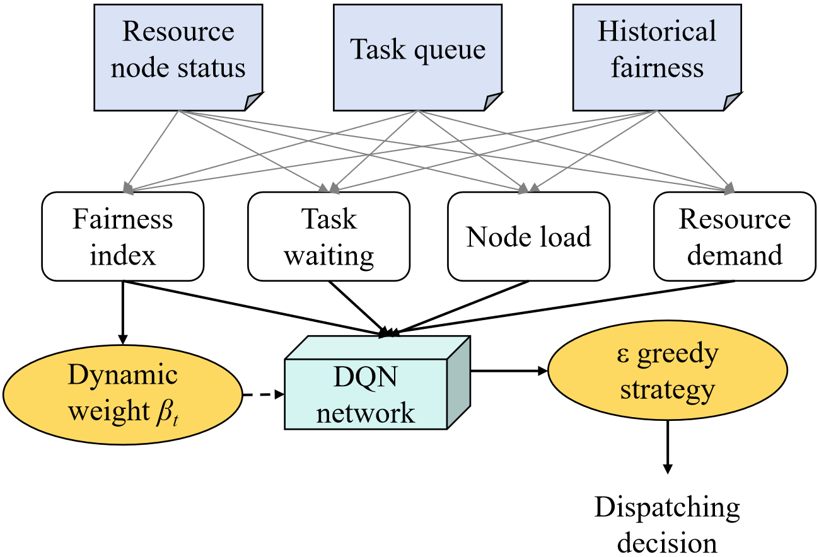
- Dynamic weight task scheduling algorithm framework
State contains the following information at time step : node load vector , where represents the current load of node . Task latency vector , where represents the current latency of task . Task resource requirements, such as CPU and memory required by each task, are simplified as vector . The moving average of composite fairness index in the past time step is used for weight adjustment:
(11)
Action represents a scheduling decision, assigning the currently arrived task to an available node. The action is a discrete value,, where is the number of nodes. If the task queue is not empty, it can be extended to select task-node pairs.
Reward combines efficiency index and fairness index , and is weighed by dynamic weight :
(12)
Efficiency index is defined as the number of tasks (i.e. throughput) completed in time step , which directly reflects the system efficiency. Negative average completion time can also be used, but the throughput is easier to calculate. The fairness index is the composite fairness index , which is recalculated at each step. The dynamic weight controls the priority of efficiency and fairness, and the range is [0, 1]. Pay attention to efficiency when approaching 1, and pay attention to fairness when approaches 0. The weight adjustment mechanism is as follows.
The weight is adaptively adjusted according to the system state to respond to the fairness requirements. Adopting feedback control based on fairness history;
(13)
Where is the weight of the previous step, and the initial value is . is the average fairness (moving average) of the past steps, reflecting the recent fairness performance. is the target fairness value, set by the platform. is the learning rate, which controls the adjustment range. The function limits to [0, 1]. When the recent fairness is lower than the target (), reduce to give priority to fairness; On the contrary, raise .
The deep Q-network (DQN) is used to learn the scheduling strategy to maximize the cumulative reward ( is the discount factor) [14]. Input the state , and output the Q value of each action . Use experience playback and target network to learn stably. Loss function is mean square error:
(14)
Where are that parameter of the online network and the target network, respectively. Use-greedy strategy to explore actions.

Experiment and result analysis

Experimental setup
Construct a discrete event simulation environment to simulate collaborative AI computing platform. Simulate a cluster with 10 heterogeneous computing nodes. The computing power (processing speed) of nodes is randomly set to 1.0 to 3.0 (unit: task/unit time) to simulate the performance difference from edge devices to cloud servers. The task arrival obeys Poisson process, and the average arrival rate can be adjusted to simulate different system loads (low, medium and high loads). The calculation amount (demand) of each task obeys the uniform distribution .
Using the proposed RL framework, the efficiency-fairness weight is fixed at 0.5 to compare the necessity of dynamic weight. The algorithm proposed in this study has the following objectives: fairness , learning rate and history window .

Results and analysis
Run the simulation under high load () scenario, and count the cumulative results after all tasks are completed, as shown in the following Table 1.

Performance comparison of various scheduling algorithms in high-load scenarios
Algorithms | System throughput (↑the better) | Average completion time (↓ the better) | Composite fairness (↑ the better)
FIFO (First-In, First-Out) | 105.2 | 18.3 | 0.62
Load Balancing (LB) | 98.7 | 20.1 | 0.75
Fixed-Weight Round Robin (F-RL) | 102.5 | 19.0 | 0.79
Dynamic-Weight Round Robin (D-RL) | 104.1 | 18.5 | 0.82

FIFO algorithm achieves the highest throughput and the shortest average completion time, but its fairness index () is significantly lower than other methods. This shows that when FIFO pursues efficiency, some tasks or nodes may not be served for a long time and the fairness is poor. LB algorithm obtains better fairness () through load balancing, but it sacrifices more system efficiency (the lowest throughput and the longest completion time) because it may assign tasks to non-optimal slow nodes for load balancing. F-RL algorithm has achieved a good balance between efficiency and fairness, but its fairness (0.79) still does not reach the target (0.8). The D-RL algorithm proposed in this study is close to the optimal FIFO in throughput and average completion time, and achieves the highest fairness (), which successfully exceeds the target value. This shows that D-RL can balance dynamically, which can ensure the high efficiency of the system and significantly improve the fairness of resource allocation.
In order to deeply explore the source of fairness improvement, the instantaneous change curves of three fairness dimensions of each algorithm are drawn during the operation under high load (taking D-RL and FIFO as examples). It can be seen from Figure 2 that the D-RL algorithm is significantly and stably higher than the FIFO algorithm in time domain fairness () and result fairness () during the whole running period. This shows that the D-RL algorithm can effectively alleviate the problems of long waiting time and large difference in completion time of some tasks in FIFO strategy. In terms of spatial fairness (), the gap between them is small, because D-RL also indirectly considers load balancing when optimizing the overall fairness.

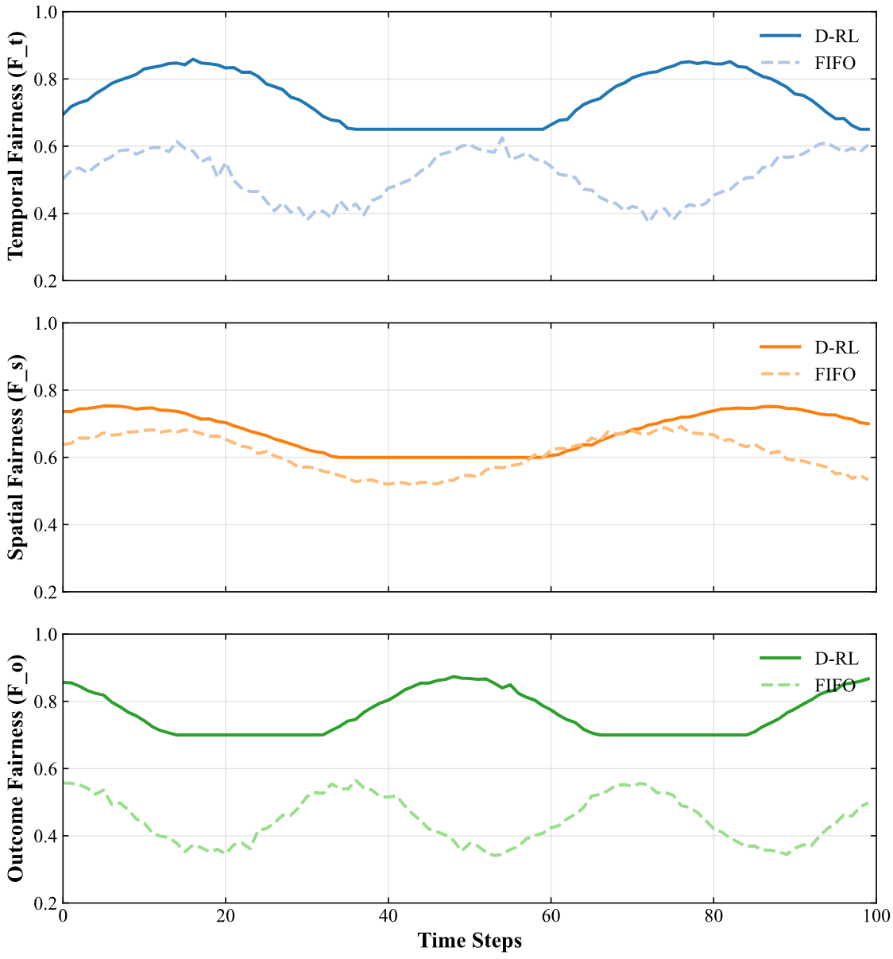
- Instantaneous value change curves of three fairness dimensions of each algorithm
In order to show the core advantages of D-RL algorithm, the change of its weight in one run and its relationship with the instantaneous fairness () of the system are monitored (see Figure 3).

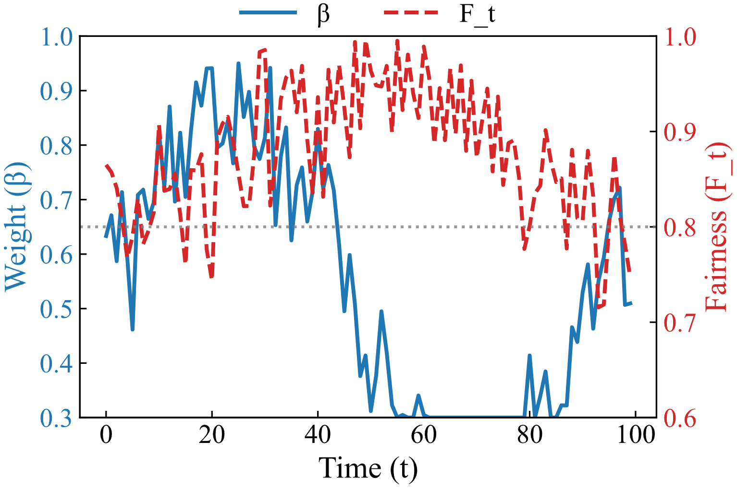
- The change of weight in one operation and its relationship with the instantaneous fairness () of the system
In the initial stage of simulation (), the system load is light, and the fairness is naturally high (). At this time, the algorithm automatically increases (close to 1), giving priority to improving efficiency, which is manifested in fast processing tasks. At around , the system may be busy due to the arrival of a batch of large-scale tasks, and the fairness decreases obviously (below the target of 0.8). The algorithm responds immediately, dynamically reduces the weight (close to 0.5), gives priority to ensuring fairness, and avoids excessive difference in task waiting time. With the recovery of system state, fairness rises, and increases gradually. This proves that the algorithm can adaptively adjust the priority of efficiency and fairness according to the real-time system state, rather than a fixed strategy.
On the premise of basically not losing the system throughput, the multi-dimensional fairness is significantly improved, and a better trade-off between efficiency and fairness is achieved. The dynamic adjustment mechanism of weight is proved to be effective, which enables the scheduling strategy to respond intelligently to changes in system load and always maintain fairness near the target level. Multi-dimensional fairness index can comprehensively and accurately reflect the unfair phenomenon in resource allocation, and provide effective quantitative guidance for scheduling decision.

conclusion
In the collaborative AI computing platform, task scheduling optimization and fairness index design are the keys to improve system sustainability and user satisfaction. In this paper, the contradiction between efficiency and fairness of traditional scheduling algorithms is effectively solved by constructing a multi-dimensional fairness quantification framework and a dynamic weight task scheduling algorithm. Experimental results show that the proposed D-RL algorithm achieves near-optimal system throughput (104.1) in high-load scenarios, and significantly improves the compound fairness (0.82), exceeding the target value. The main conclusions are as follows:
1)The fairness of resource allocation can be quantified by Gini coefficient in time domain, space domain and result dimension, which can fully reflect the consistency of task waiting time, node load balance and task completion quality. The model avoids the one-sidedness of a single index and provides effective quantitative guidance for scheduling decision.
2)The adaptive task scheduling algorithm based on DQN can dynamically adjust the weight of efficiency and fairness according to the system state. The simulation results show that D-RL algorithm can intelligently respond to system changes under different load conditions, giving priority to ensuring fairness or efficiency, thus achieving better resource allocation.
3)On the premise of not losing the system throughput, the D-RL algorithm significantly improves the multi-dimensional fairness, and successfully alleviates the problems of long task waiting time and large difference in completion time in FIFO strategy. Experimental data show that D-RL is superior to other algorithms in time domain and fairness of results, which proves its core advantages.

References

- Sivalingam M S ,Kumar P P .Pufferfish: Cost-aware based task scheduling algorithm using pufferfish optimization algorithm in cloud computing[J].Intelligent Decision Technologies,2025,19(4):2788-2798.DOI:10.1177/18724981251319611.
- Li Z ,Zheng K .Batched split learning: a novel framework for low-latency and energy-efficient split learning with optimized task scheduling[J].Wireless Networks,2025,31(6):1-19.DOI:10.1007/S11276-025-03994-4.
- Radhika D ,Duraipandian M .Optimized dynamic task scheduling in cloud computing for big data processing[J].Wireless Networks,2025,31(5):1-12.DOI:10.1007/S11276-025-03954-Y.
- Xie Z ,Liu J ,Ji Y , et al.ACO intelligent task scheduling algorithm based on Q-learning optimization in a multilayer cognitive radio platform[J].SIMULATION,2025,101(5):509-537.DOI:10.1177/00375497231208481.
- Wu L ,Li S ,Wu F , et al.Multi-strategy Enhanced Hiking Optimization Algorithm for Task Scheduling in the Cloud Environment[J].Journal of Bionic Engineering,2025,22(3):1-29.DOI:10.1007/S42235-025-00674-Z.
- Vasantham K V ,Donavalli H .Cost minimization approach with hybrid optimization based task scheduling in Geo-distributed cloud[J].Australian Journal of Electrical and Electronics Engineering,2025,22(2):169-181.DOI:10.1080/1448837X.2024.2355004.
- Wang M ,Pei C ,Chen X , et al.A dynamic decomposition optimization framework for multi-satellite scheduling of area target observation[J].Advances in Space Research,2025,75(6):4664-4681.DOI:10.1016/J.ASR.2025.01.011.
- Acharya B ,Panda S ,Das S , et al.Optimizing task scheduling in cloud environments: a hybrid golden search whale optimization algorithm approach[J].Neural Computing and Applications,2025,37(17):1-23.DOI:10.1007/S00521-025-11113-9.
- Monika ,Sehrawat H .Multi-parametric and priority driven particle swarm (MPPPSO) optimized task scheduling approach for improving performance of fog computing system[J].Progress in Artificial Intelligence,2025,14(3):1-18.DOI:10.1007/S13748-025-00366-Z.
- Pramanik D K P ,Biswas T ,Choudhury P .Particle swarm optimization-based load balance-aware energy-efficient scheduling for mobile crowd computing[J].SIMULATION,2025,101(2):159-176.DOI:10.1177/00375497241298346.
- Luo Q ,Huang S ,Li W , et al.Research on Optimization of Maintenance Task Scheduling for Metro Systems Based on Resource Constraints[J].Transportation Research Record,2025,2679(2):1-17.DOI:10.1177/03611981241257412.
- Kumar R ,Vardhan M .IBWC: a user-centric approach to multi-objective cloud task scheduling using improved beluga whale optimization[J].Knowledge and Information Systems,2025,67(4):1-35.DOI:10.1007/S10115-024-02325-X.
- Kaur S ,Singh J,Bharti V.An optimised AI-driven swarm-based enhanced task scheduling model for cloud computing environment[J].International Journal of Cloud Computing,2025,14(1):25-53.DOI:10.1504/IJCC.2025.145660.
- Tamilarasu P ,Singaravel G .Quality of service aware improved coati optimization algorithm for efficient task scheduling in cloud computing environment[J].Journal of Engineering Research,2024,12(4):768-780.DOI:10.1016/J.JER.2023.09.024.

